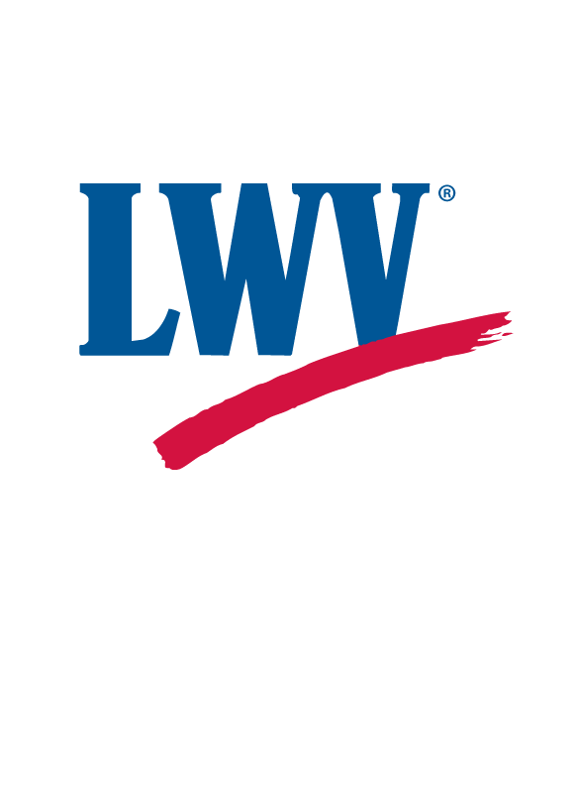2017 ANNUAL MEETING of the
League of Women Voters – Lower Cape Fear

DATE: Monday, June 26th
ACTIVITIES: Social Time & Appetizers at 6 PM
Buffet Dinner at 6:30
Annual Business Meeting c. 7:00
VENUE: Charlie Macgrooders
LOCATION: 117 Village Road in Leland
RSVP Please mail your check, payable to LWV-LCF, for the dinner ($25) by June 12
MAIL TO: LWV-LCF
PO Box 4503
Wilmington NC 28406
Enjoy the fellowship of members and prospective members! Celebrate a year of accomplishments, growth, and learning under the leadership of our President, Board, Chairs, and all our members.
You will have an opportunity to pay your annual dues at this meeting.

